

Foundations of Programming

Assignment No.: 17
PROBLEM STATEMENT: To accept the number of terms and find the sum of the sine series.

OBJECTIVE:

- To understand the concept of mathematical series in programming.
- To implement sine series using C programming.
- To practice loops and arithmetic operations.
- To learn the use of factorial and power calculations in C.

THEORY:
In mathematics, the sine function can be expressed as an infinite series called the Taylor series expansion. The sine series is represented as:
sin(x) = x − x^3/3! + x^5/5! − x^7/7! + ...

In this program, the user enters the value of x and the number of terms. The program calculates the sum of the sine series up to the specified number of terms using loops. Factorial and power operations are used to compute each term of the series.
PLATFORM: Linux

INPUT: Value of x and number of terms.

OUTPUT: Displays the sum of the sine series.

CODE:
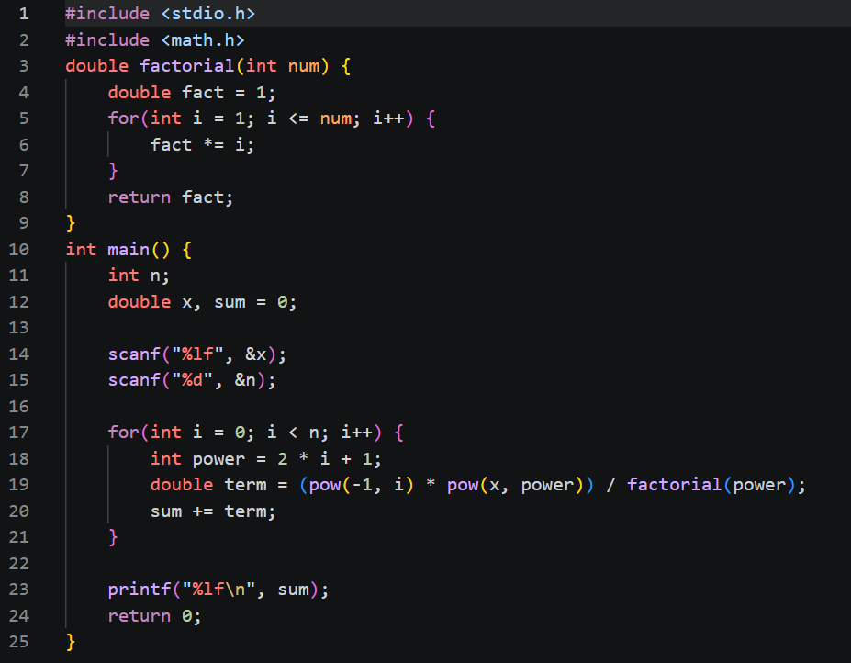

SAMPLE INPUT:
Enter value of x (in radians): 1
Enter number of terms: 5

SAMPLE OUTPUT:
Sum of sine series = 0.841471

CONCLUSION: Thus, the C program successfully calculates the sum of the sine series for the given number of terms.

FAQs:
- What is a sine series in mathematics?
Soln: A sine series is an infinite mathematical series used to represent a function as a sum of sine-based terms. For example, the series expansion of sin(x) is given by sin(x) = x − x³/3! + x⁵/5! − …, where the terms involve alternating signs, odd powers of x, and factorials in the denominator. This series helps in approximating the value of the sine function accurately and is widely used in mathematics, physics, and engineering.
2.Why is factorial used in the sine series?
Soln: Factorial is used in the sine series because it naturally arises from the Taylor (Maclaurin) expansion of functions, helping to scale each term correctly. As the powers of (x) increase, the factorial in the denominator grows very quickly, which makes the terms smaller and ensures the series converges to an accurate value of sin(x). In simple terms, factorial keeps the higher-power terms from becoming too large and allows the series to approximate the sine function precisely.

3.Why does the sine series have alternating signs?
Soln: The sine series has alternating signs because of the pattern that arises when deriving it from the Taylor (Maclaurin) expansion of sin(x). The derivatives of sin(x) cycle between positive and negative values (sin x, cos x, −sin x, −cos x, …), which introduces alternating positive and negative terms in the series. This alternating pattern helps balance the approximation, improving accuracy and ensuring the series converges properly to the actual value of sin(x).

4.Which header file is required for power functions in C?
Soln: The header file required for power functions in C is <math.h>. It provides the pow() function, which is used to calculate powers of a number.

5.How does increasing the number of terms affect accuracy?
Soln: Increasing the number of terms improves accuracy because more terms make the series approximation closer to the actual value of sin(x). Each additional term adds a finer correction, reducing the error between the calculated and true value. As the number of terms increases, the result converges more precisely to the real sine value.

